**COMPONENTS**

1 x NodeMCU

1 x Buck convertor

1 x LM1117 Transistor

2 x 10uF capacitors

2 x 1 channel modules

3 LEDS : 1 GREEN, 1 RED, 1 YELLOW

3 x 220Ω resistors

1 x Terminal Block

1 x Jumper

Male header pins and Female header pins

**FABRICATION PROCESS**

The circuit was designed using Proteus which is a PCB Design and Circuit Simulator Software.

The circuit designed was as follows:

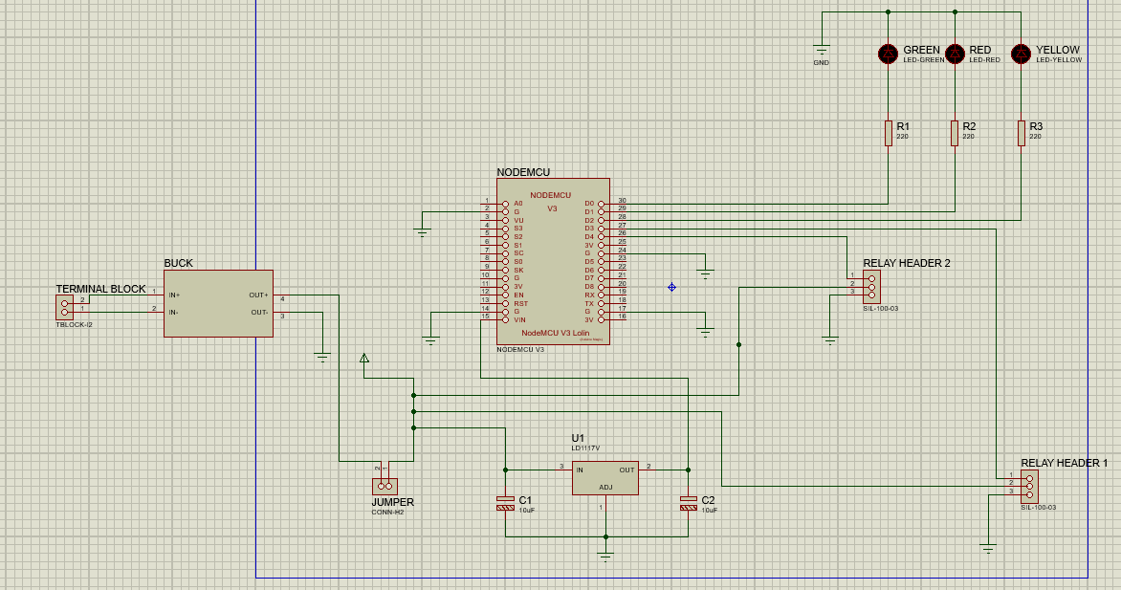**fig.1**

The components were measured and the board size was chosen to fit all the components.

The PCB layout was generated and the components were routed.

The layout created is shown in **fig.2** below

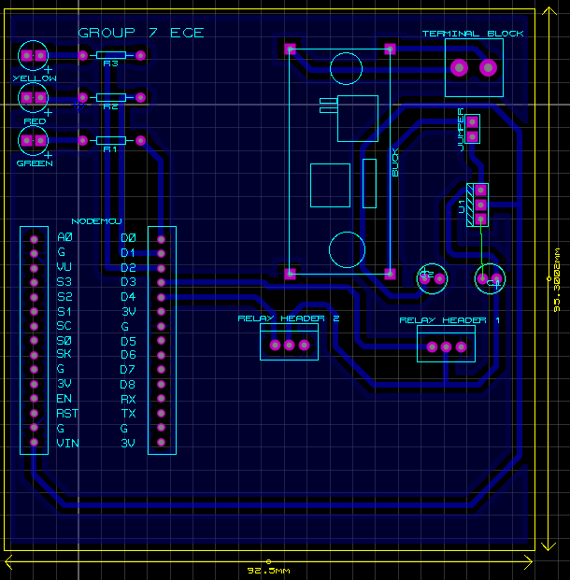

**Fig.2**

The 3D layout generated by proteus was shown as in **fig.3** below

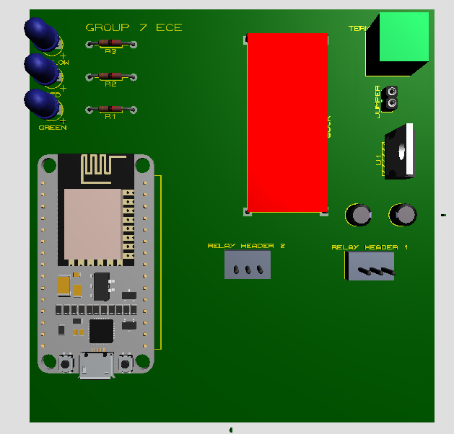

**Fig.3**

After finishing the design, a gerber file was generated and exported.

A gerber file containing the drill holes was generated.

The gerber file containing the artwork was printed on a special paper called laser film.

Using routepro3000, a software program used to operate the CNC machine used to drill holes as shown in **fig.4**.

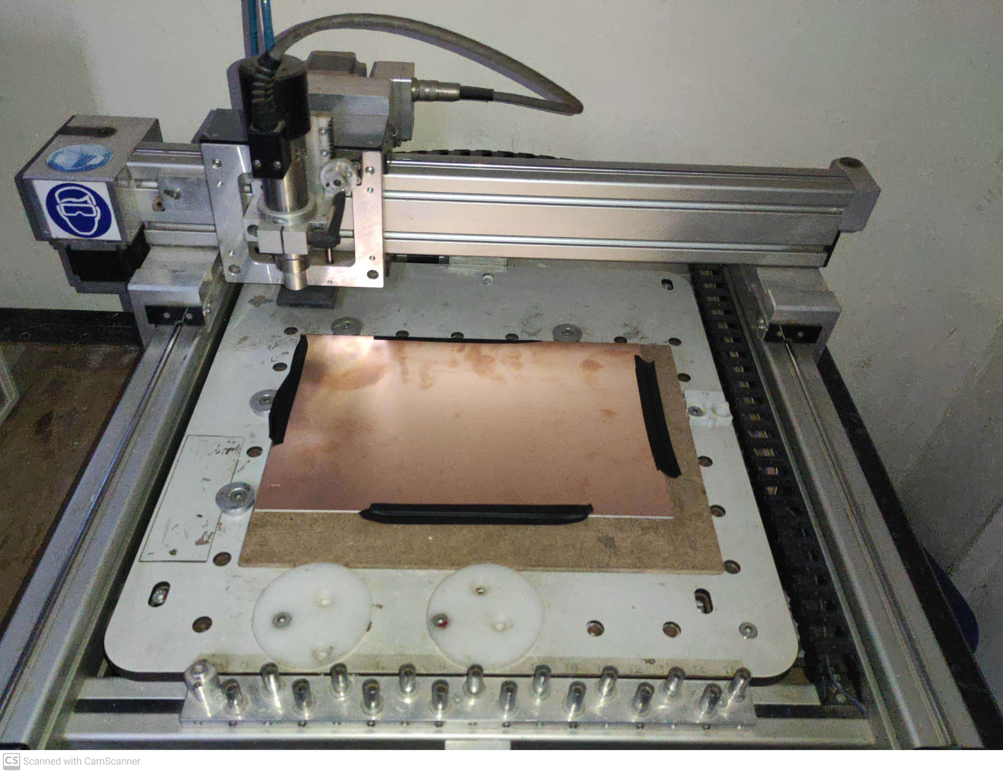

**Fig. 4**

The Drill file was loaded to the program

From within the program, choosing of the drill bit for different hole sizes was done as shown in **fig.5**.

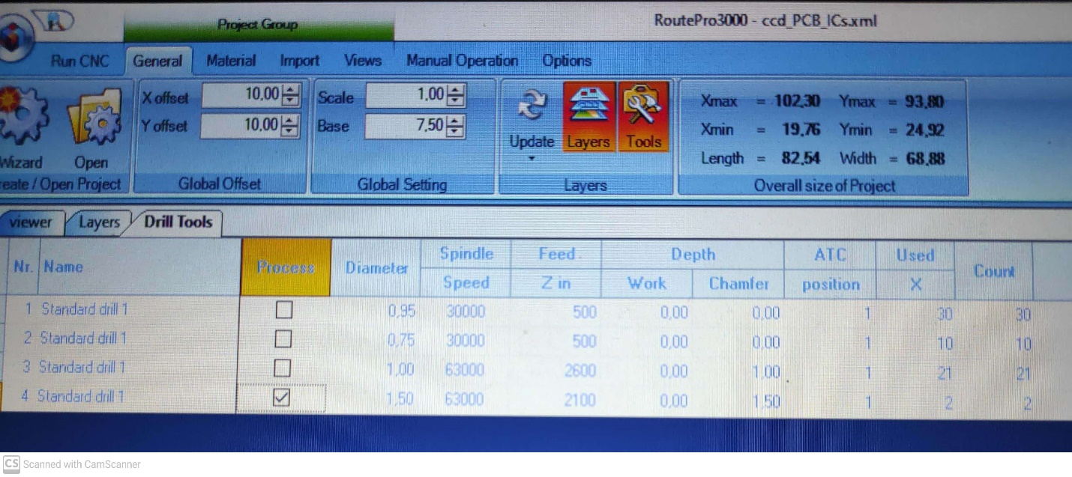

**Fig. 5**

A Guillotine was used to cut the size of board required.

The holes were buffered to smooth out the rough edges caused by drilling of holes.

The board was then laminated on the bottom side to make sure there are no air gaps using photoresist.

The machine used is a UV laminator.

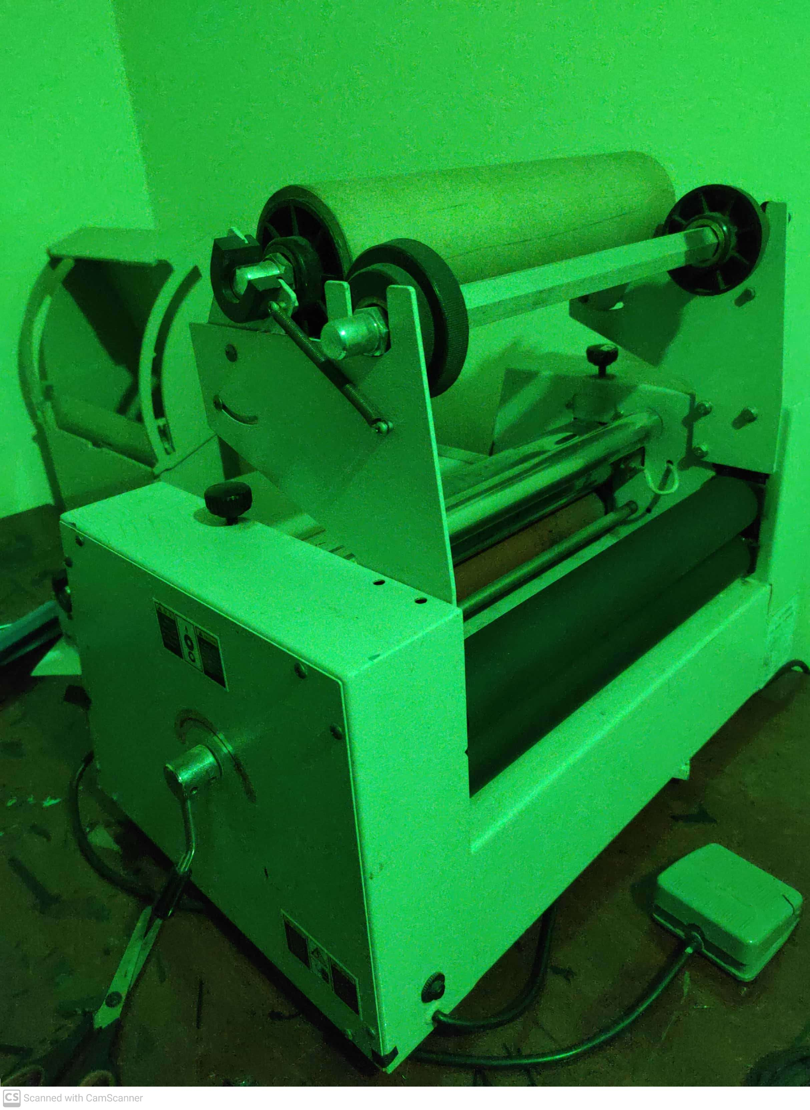

**U.V laminator**

The board was repeatedly passed through the laminator until it the photoresist was firmly gripped on the board as shown in **fig.6**.

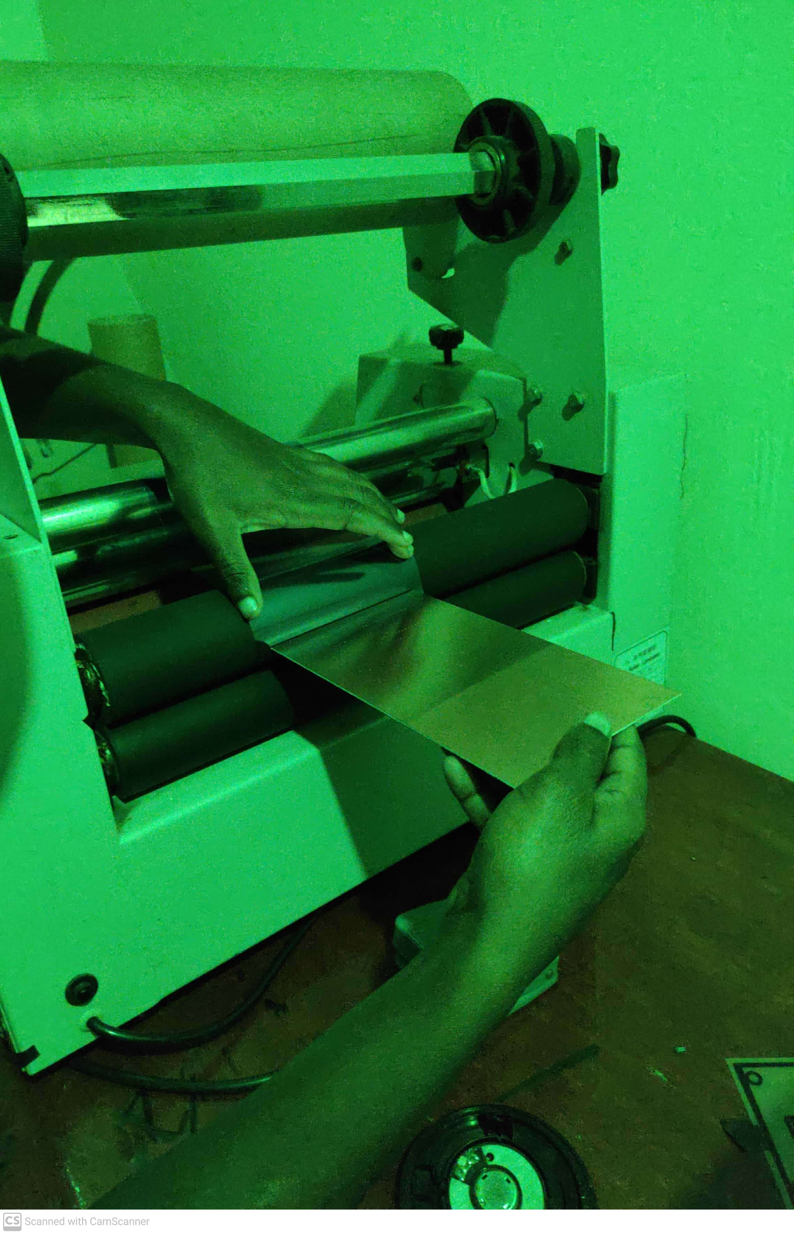**fig.6**

The printed artwork was aligned with the bottom side of the board.

For 5seconds, the board was exposed to UV light in the machine displayed in **fig.7**

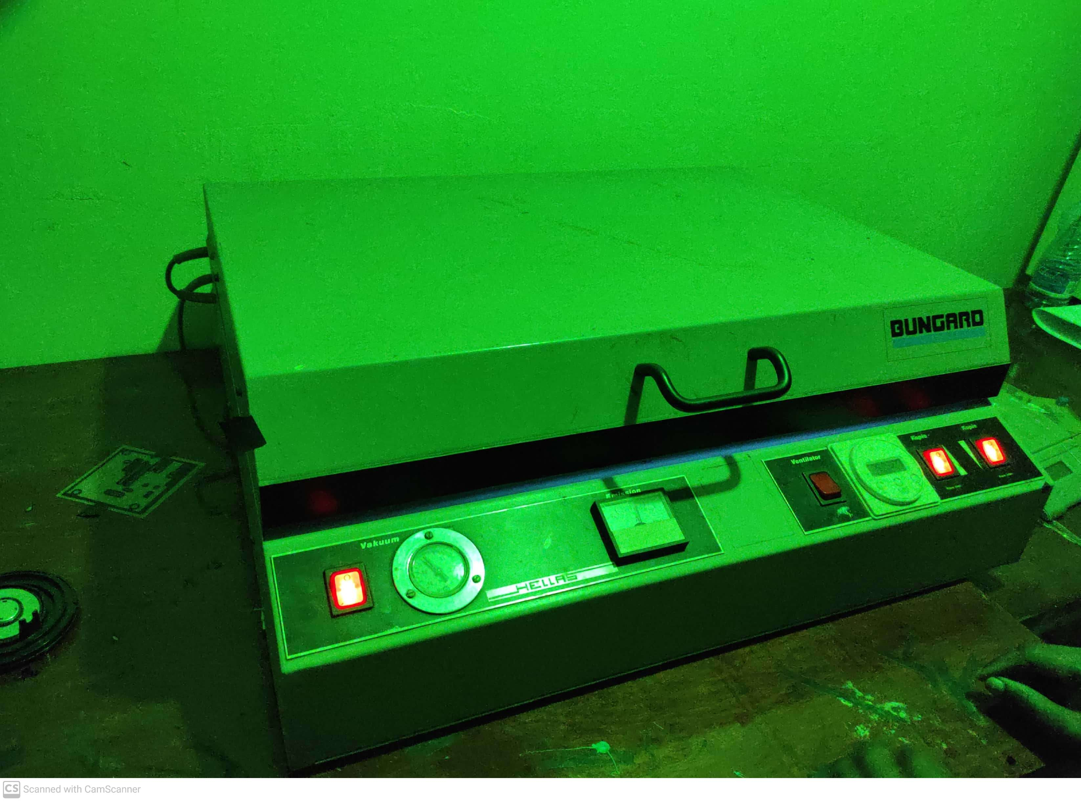

**Fig.7**

and the result was as shown in **fig.8** below

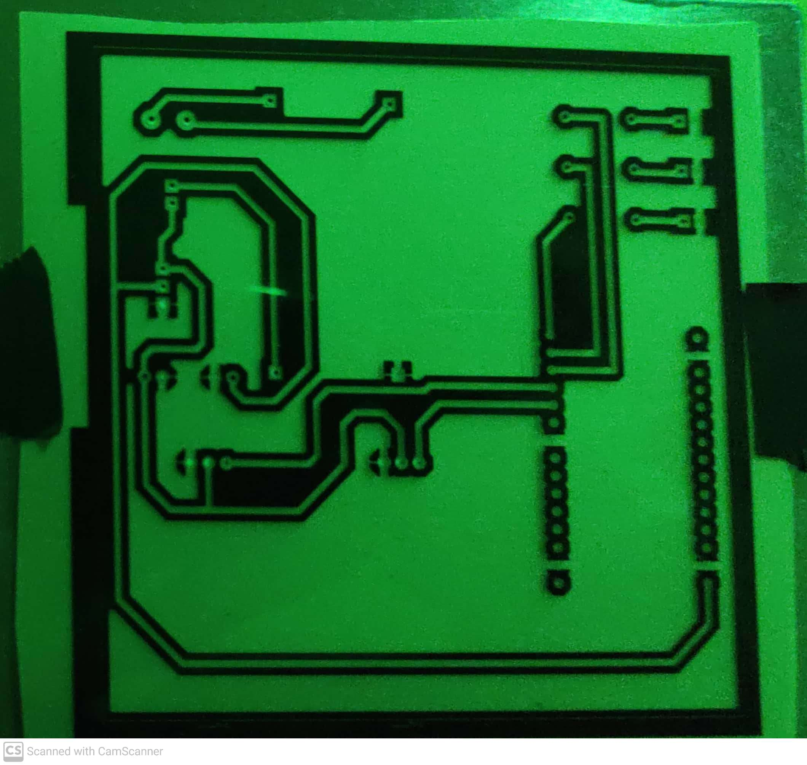

**Fig.8**

The resist was generated using the spray imaging machine.

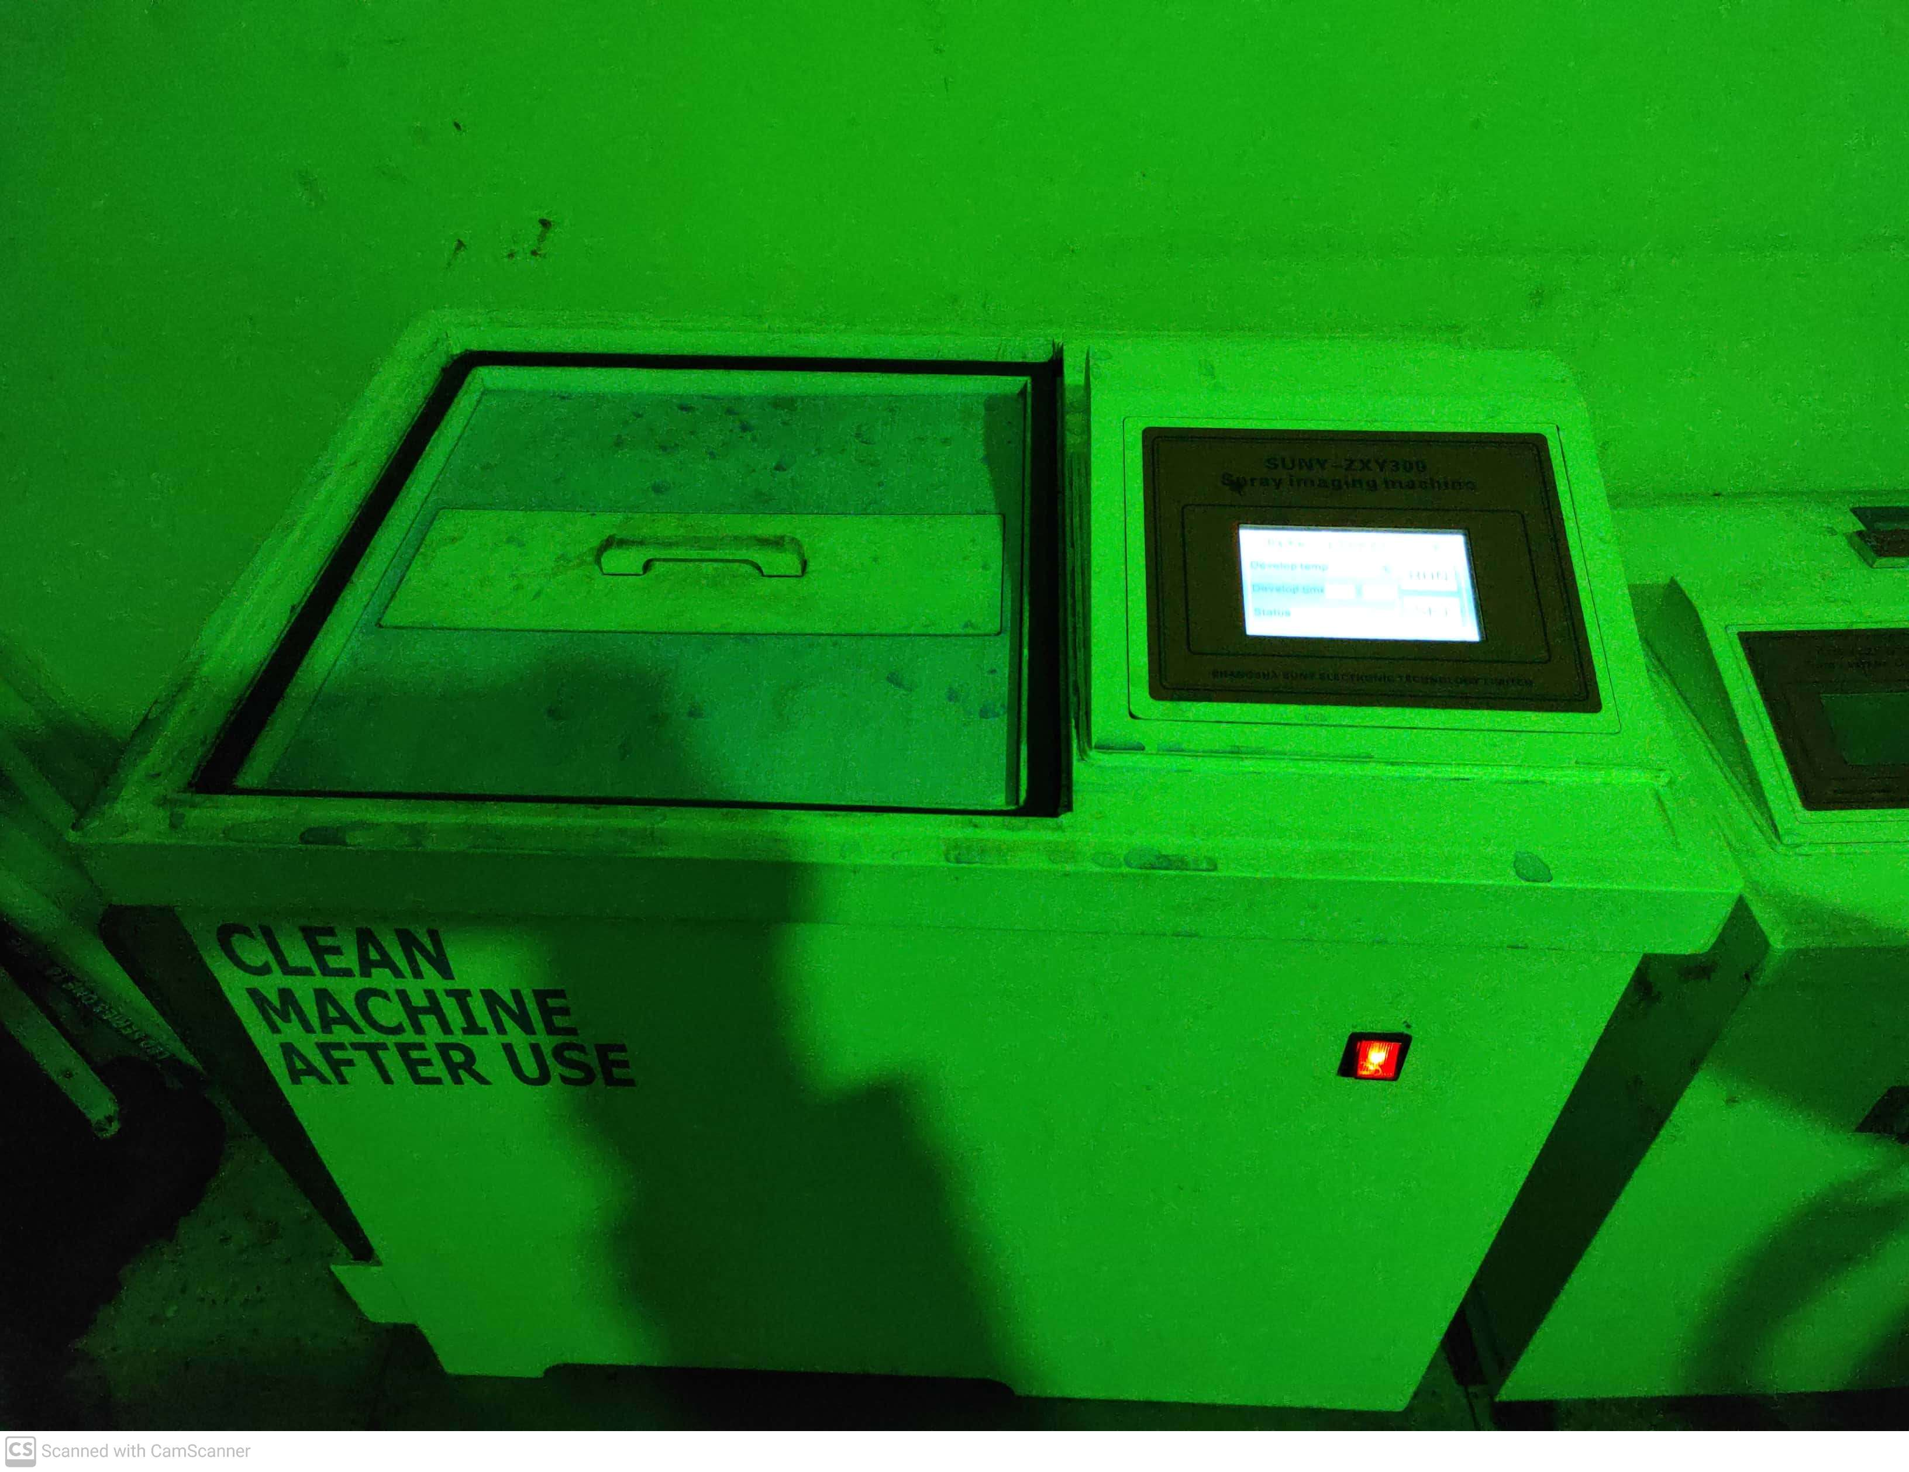

**Spray Imaging Machine**

It was then exposed to uv light for a few more seconds.

After that, it was put in the oven for about 3mins

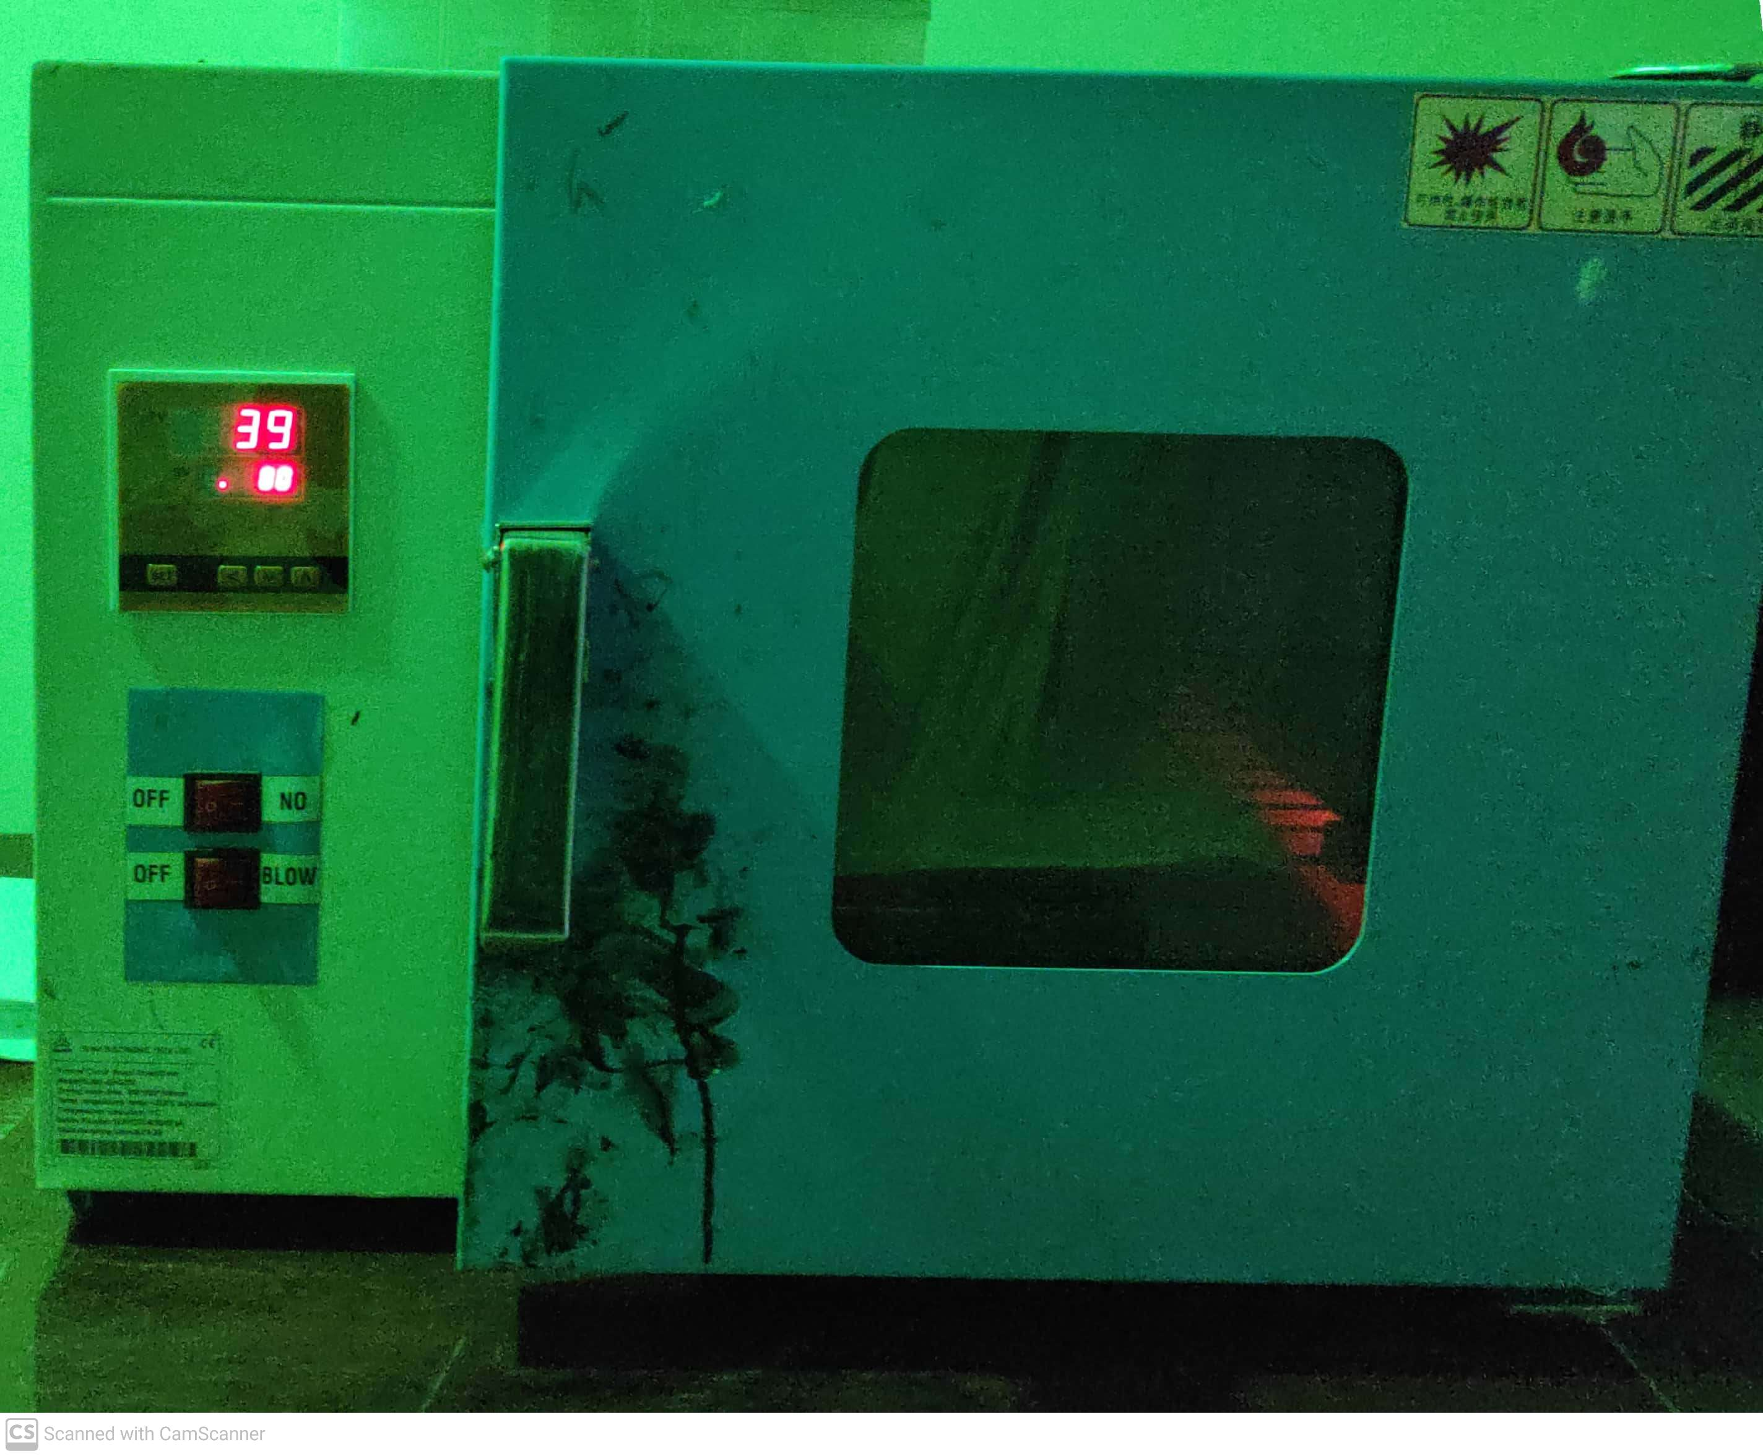

**Oven**

The resulting board was as follows:

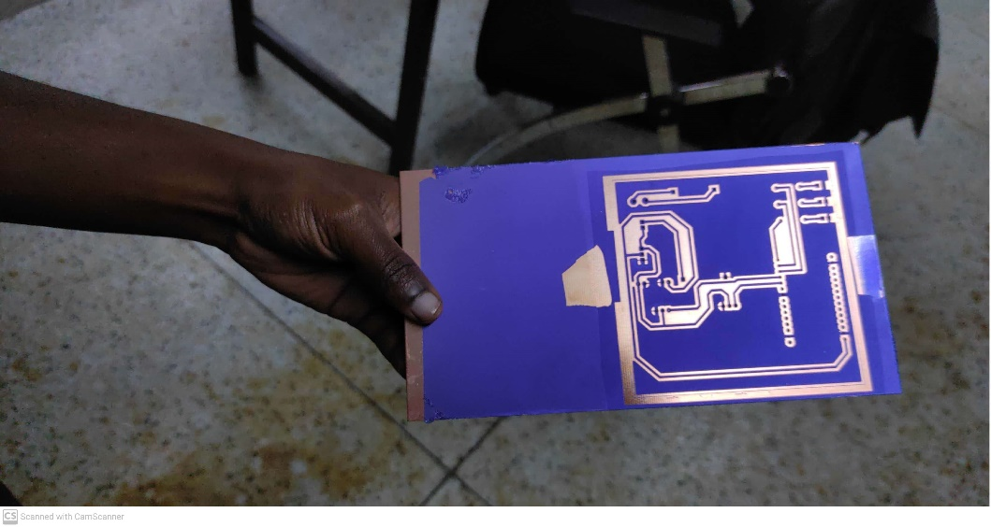

Etching was done for 10mins to complete the process

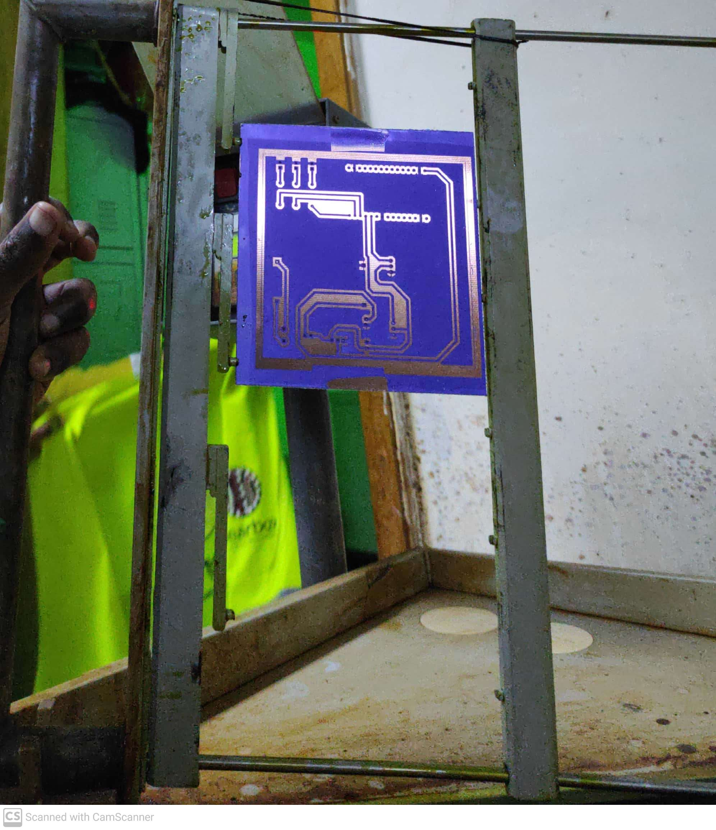

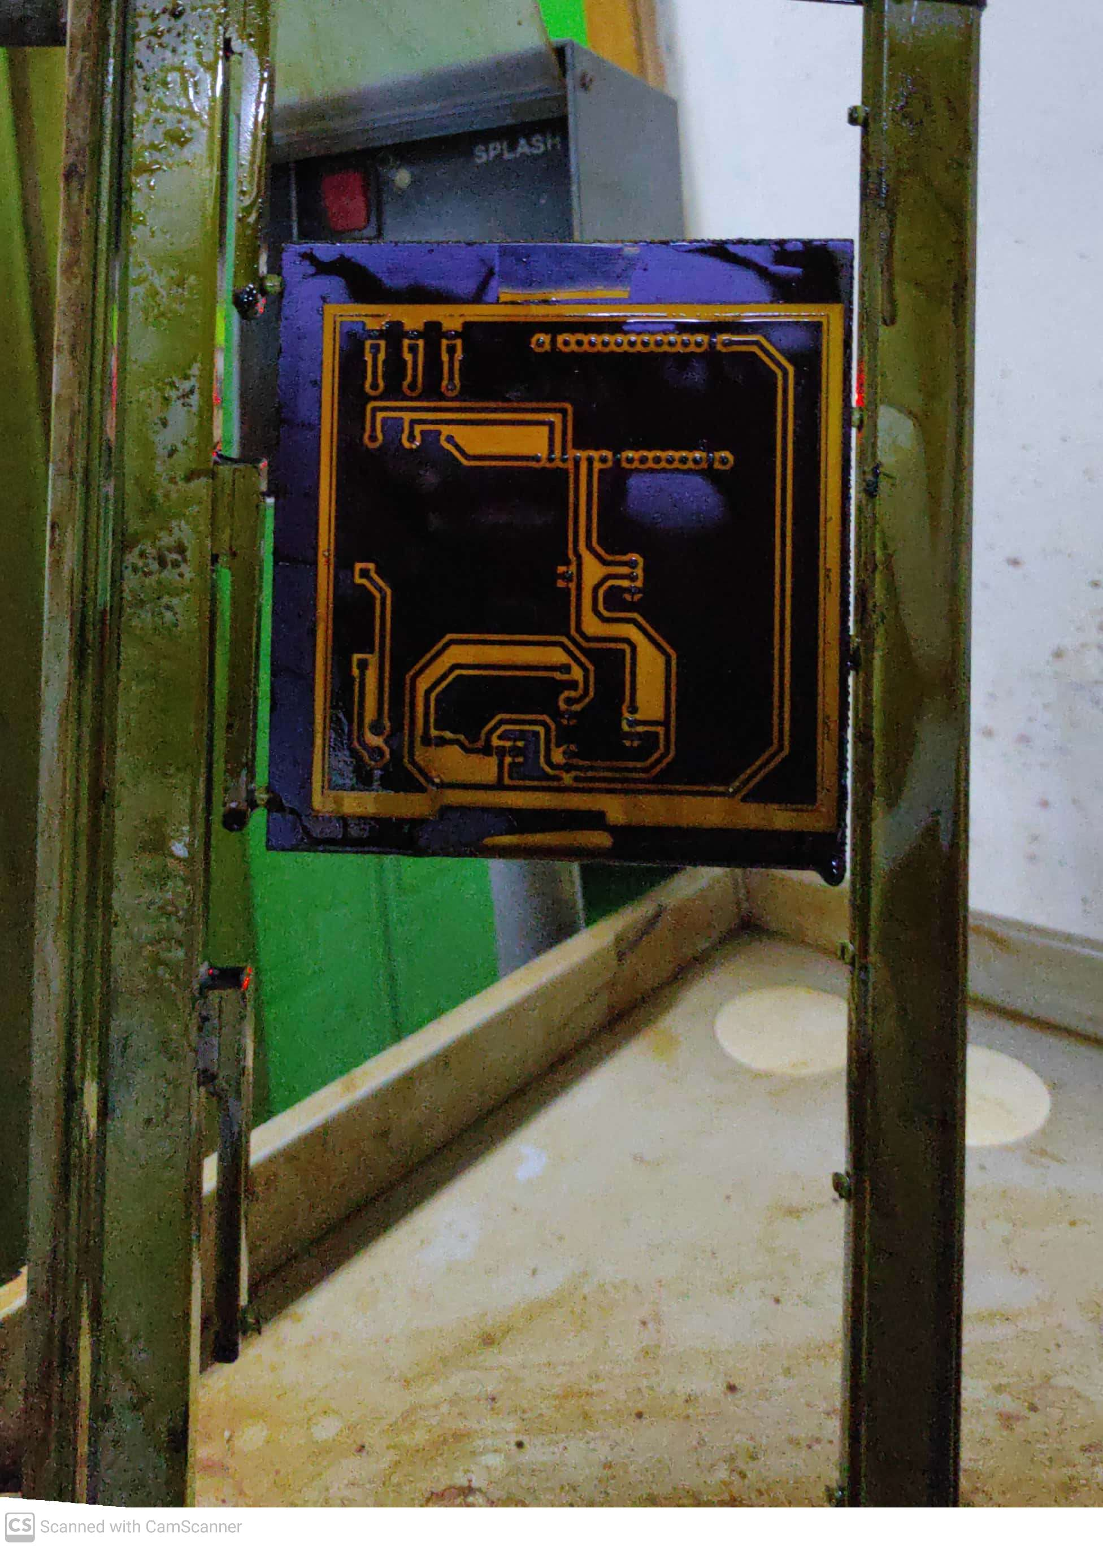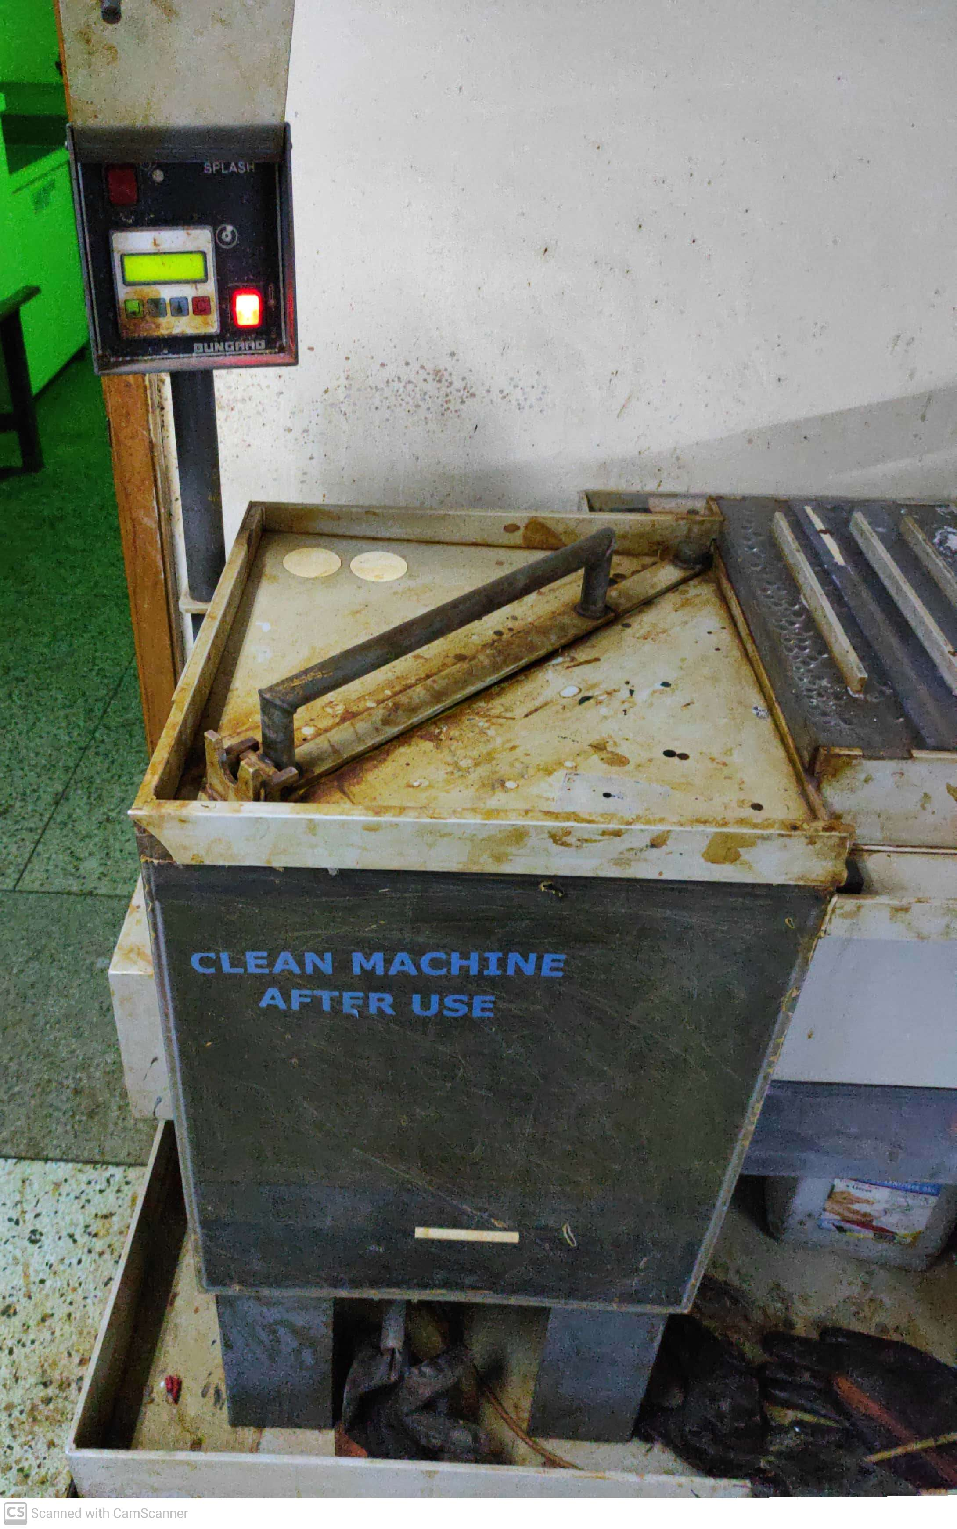

ETCHING MACHINE

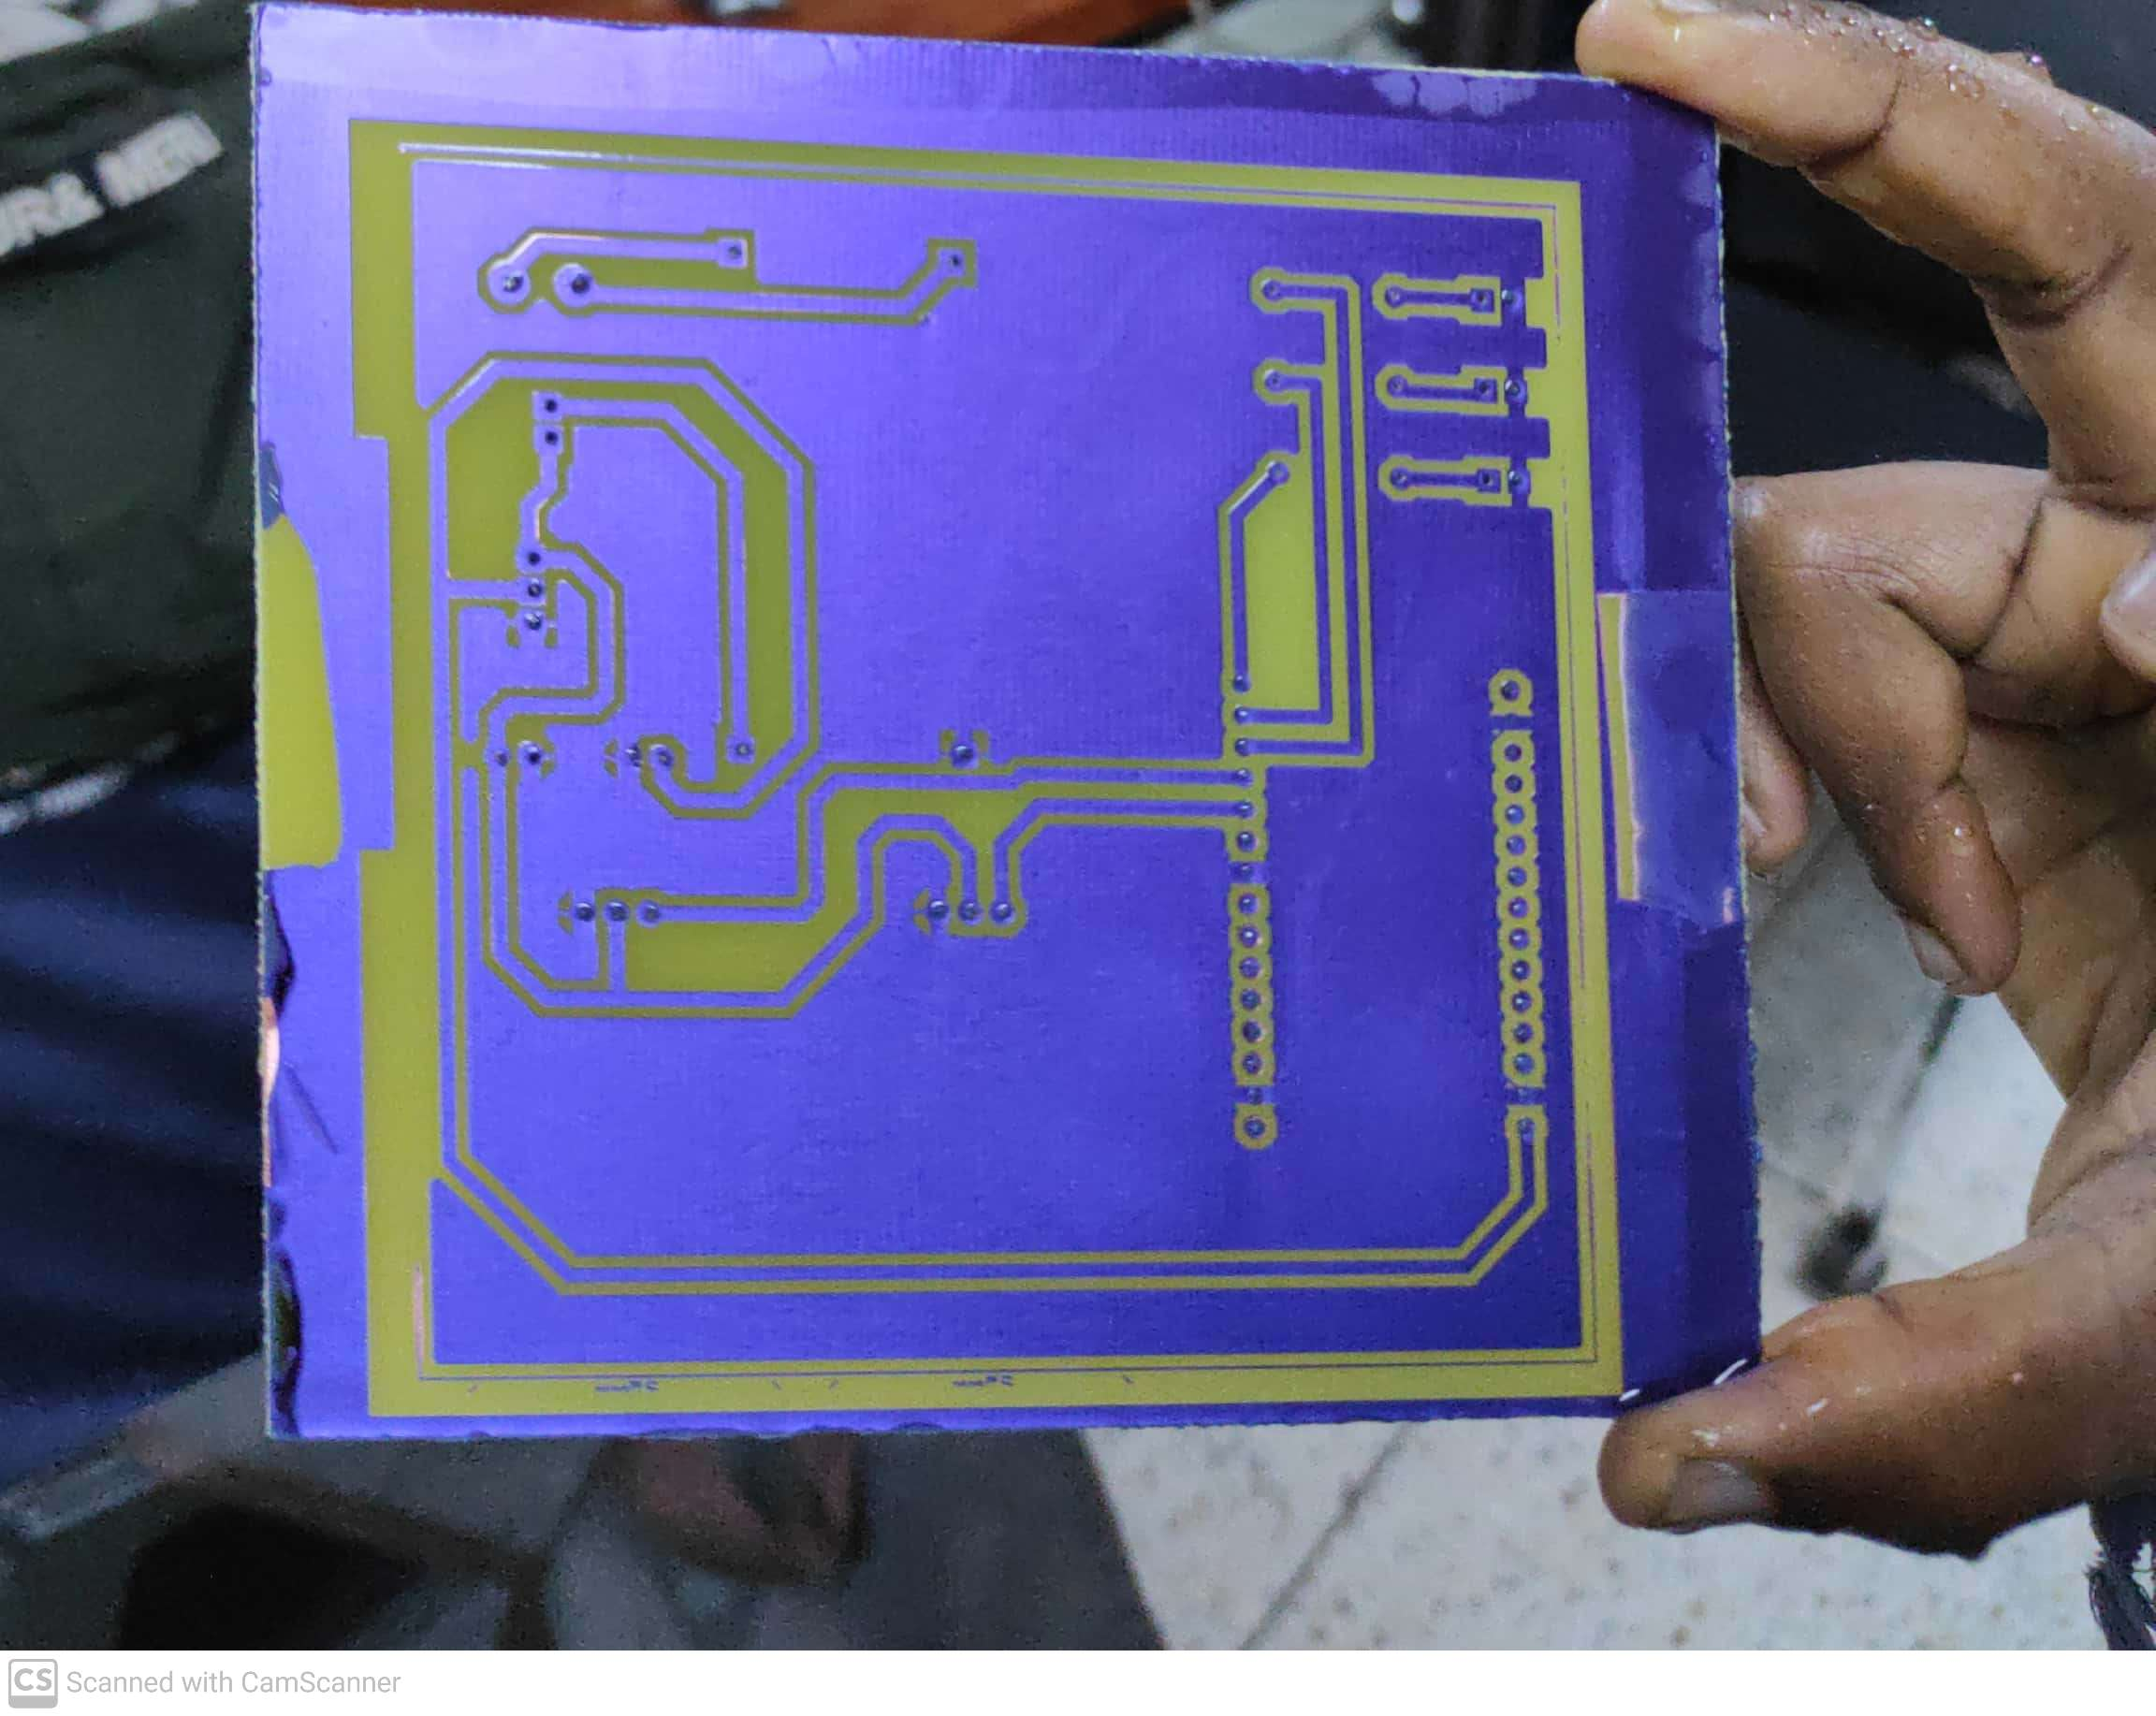

RESULTING BOARD

The resist was then stripped, wiped and cleaned off the etchant and the components soldered on the board.